SIMATS ENGINEERING
Department of Information Technology
CSA15 – CLOUD COMPUTING AND BIG DATA ANALYTICS
ASSIGNMENT 2 – CO2
Analyse, Evaluate and Validate a Virtualization Architecture for a Multi-Tenant University Private Cloud CO2: Analyze virtualization architectures to identify performance and security issues in cloud computing environments.
Field | Details | Field | Details
Student Name | Sandesh S | Register Number | 192521078
Department / Section | Information Technology | Academic Year / Semester | 2025-2029
Faculty Name | R LATHA | Nature of Assignment | Individual
Duration | 1 Week | Total Marks | 50
Submission Date |  | Evaluation Date
MARK SHEET (Rubric-based evaluation)
Task | Title | Max | Awarded | Evidence / evaluation focus
1 | Characterise the Virtualization Architectures | 5
2 | Identify the Dominant Overhead Source | 2

Task | Title | Max | Awarded | Evidence / evaluation focus
3 | Build a Quantitative Performance  Model | 6
4 | Analyse Performance Under Different Conditions | 4
5 | Security Threat and Vulnerability Analysis | 3
6 | Formulate Isolation–Performance Trade-off | 3
7 | Evaluate Mitigation Strategies | 4
8 | Implement and Test | 4
9 | Record Experimental Performance | 3
10 | Compare Theory with Experiment | 4
11 | Recommend and Defend Final Architecture | 4
 | Day-4 Design Challenge | 8

TOTAL
50
OVERALL REMARKS
Overall, the assignment reflects good analytical ability, technical understanding and problem-solving skills in cloud computing and virtualization. The proposed architecture balances performance, security, resource efficiency and future scalability. The work can be further strengthened through verified experimental results, consistent benchmark comparisons and practical validation of the recommended security controls.
Student Signature | Faculty Signature | Program Director
MANDATORY SUBMISSION EVIDENCE CHECK
= Present in documented answer; P = Partly present; X = Missing / not satisfied
Task | Evidence expected | Status | Evaluator note
1 | Three virtualization architectures, layered diagrams and trust boundaries
2 | Dominant overhead source identified and explained for each approach
3 | CPU, memory, I/O, network and density models with assumptions
4 | Best, typical and worst operating-condition analysis

Task | Evidence expected | Status | Evaluator note
5 | Threat model and architecture-based security comparison
6 | Isolation–performance optimization formulation
7 | Mitigation benefits, residual risks and quantified costs
8 | Reproducible setup and practical tests across selected platforms
9 | Actual comparative measurements, table and two graphs
10 | Theory–experiment comparison and quantitative error analysis
11 | Justified SIS/LMS architecture and growth recommendation
12 | Day-4 external tenants, 3× peaks, live migration and SIS isolation
IMPLEMENTATION EVIDENCE CHAIN
Evidence item | Status | Observation
Architecture diagrams
Performance model

Evidence item | Status | Observation
Configuration / scripts
Virtualization experiments
CPU / disk / network / memory tests
Noisy-neighbour experiment
Security validation
Tables and graphs
Theory–experiment consistency
Day-4 design defence
Screenshots
SUBMISSION CHECKLIST (Not Separately Marked)
Requirement | Status
All 12 tasks answered | Yes | Partly | No
Three virtualization approaches compared | Yes | Partly | No
Layered diagrams and trust boundaries included | Yes | Partly | No
Quantitative virtualization models included | Yes | Partly | No
Threat analysis and mitigations included | Yes | Partly | No

CLOUD COMPUTING AND BIG DATA
ASSIGNMENT 2
CO2: Analyze virtualization architectures to identify performance and security issues in cloud computing environments.
_________________________________________________________________

Assignment Title: Analyse, Evaluate and Validate a Virtualization Architecture

for a Multi-Tenant University Private Cloud (Total Marks: 50) Duration: 1 week
_________________________________________________________________

Scenario: EduCloud Virtualization Platform
A university runs a private cloud, EduCloud, in its data centre. EduCloud currently consists of:
- 16 physical hosts, each with 64 CPU cores, 512 GB RAM, NVMe SSD storage and 2 × 25 Gbps NICs
- About 400 virtual machines (VMs) running the Student Information System (SIS), the Learning Management System (LMS), the examination portal, and departmental research workloads
- A shared storage backend and a software-defined virtual network
During semester registration week, users report slow response times and failed logins. A recent internal security audit also found that VMs from different departments share the same physical hosts, that some VMs run outdated guest kernels, and that VM images are copied freely between teams.
You are the cloud architect. You must investigate, model, measure and compare virtualization architectures for EduCloud, identify their performance bottlenecks and security weaknesses, and recommend a design that remains practical as the platform grows.

Design Challenge:
The university now plans to host external research collaborators' big-data workloads (Spark/Hadoop clusters) on the same infrastructure as the SIS. Reevaluate your design under these new multi-tenant conditions.

TASK 1: Characterise the Virtualization Architectures (5 Marks)

Select at least three meaningfully different virtualization approaches from the following, or justify others:
- Type-1 (bare-metal) hypervisor with full virtualization
- Type-2 (hosted) hypervisor
- Hardware-assisted virtualization vs. paravirtualization
- OS-level virtualization (containers)
- Lightweight/micro-VM or sandboxed container runtimes
Two configurations of the same hypervisor will not count as different approaches. Your selection must include at least one VM-based and at least one container-based approach.
For each approach, provide:
- A layered architecture diagram showing the hardware, host OS or hypervisor, guest OS, runtime and application
- The trust boundaries and the component that enforces isolation
- How CPU, memory, storage and network are virtualized
- A brief justification for why this approach is relevant to EduCloud
Evidence expected: Three architecturally distinct approaches with labelled diagrams, resource-virtualization mechanisms, trust boundaries, and justification of selection.

TASK 2: Identify the Dominant Overhead Source (2 Marks)
For each approach, identify the primary source of performance overhead that predominantly limits its performance (for example VM exits/traps, nested or extended page-table walks, virtual I/O emulation, virtual switch processing, or system-call interception).
Discuss:
- What the overhead source is
- Where in the architecture it occurs
- Why it is appropriate as the focus of performance analysis
- How its frequency or cost changes as the number of co-located VMs/containers or the I/O rate increases
Do not simply name a mechanism. Relate it to the behaviour of the architecture.
Evidence expected: A justified dominant-overhead identification for each approach, linked to its resource-virtualization path.

TASK 3: Build a Quantitative Performance Model (6 Marks)
Using the following host parameters, develop an analytical performance model for each approach.
Parameter | Value
Physical cores per host | 64
vCPU:pCPU overcommit ratio | 1:1 , 2:1, 4:1, 8:1
RAM per host | 512 GB
Average VM memory demand | 8 GB
Cost of one VM exit (assume) | 1.5 µs
Native system-call cost (assume) | 0.2 µs
Network line rate | 25 Gbps

State and justify any additional assumptions. Derive expressions for:
- CPU: effective per-VM CPU capacity as a function of overcommit ratio and virtualization overhead (including steal time)
- Memory: the maximum number of VMs per host before ballooning, swapping or page-sharing becomes necessary
- I/O and network: effective throughput as a function of the number of VMs sharing the physical device
- Density: the number of VMs/containers a host can support while meeting a stated service-level target (for example, ≤ 10% performance degradation)
Show the mathematical reasoning. Merely quoting overhead percentages from the literature will not receive full credit.
Evidence expected: A clear mathematical derivation for each approach, with stated assumptions, parameter values and worked numerical examples.

TASK 4: Analyse Performance Under Different Operating Conditions (4 Marks)
Analyse how each approach behaves under three conditions:
- Best case: what workload and placement conditions minimise overhead?
- Typical case: for example, registration-week mixed web and database load
- Worst case: for example, noisy-neighbour interference, memory overcommit with swapping, live migration during peak load, or I/O storms
For each, explain what happens inside the virtualization layer, why the overhead changes, and how latency and throughput are affected. A table of numbers alone will not be accepted.
Evidence expected: A justified condition-based analysis supported by your Task 3 model.

TASK 5: Security Threat and Vulnerability Analysis (3 Marks)
Construct a threat model for each approach. Discuss:
- The attack surface (hypervisor, device emulation, shared kernel, management plane, VM images and snapshots, virtual network)
- At least four distinct threat categories, such as VM escape, cross-VM side-channel attacks, hypervisor or container-runtime vulnerabilities, VM sprawl and unpatched guests, image tampering, insecure live migration, and virtual-network sniffing or spoofing
- For each threat, which approach is more or less exposed and why, referring to its architecture and trust boundaries
- The likely impact on the confidentiality, integrity and availability of student records
Evidence expected: A structured threat model mapped to architectural features, with a justified comparison across approaches.

TASK 6: Formulate the Isolation–Performance Trade-off (3 Marks)
Formalise the trade-off between isolation strength and performance/density for EduCloud.
Clearly identify:
- The decision variables (for example, approach chosen, VMs per host, dedicated vs. shared hosts, SMT on/off)
- The objective(s), such as maximising density or minimising cost
- The constraints (for example, performance degradation limit, isolation requirement for SIS, available hosts)
- How these components combine into a cost or decision function
The formulation must follow from your own analysis in Tasks 3 and 5, not from a generic template.
Evidence expected: A clearly defined trade-off model with identified variables, objective and constraints.

TASK 7: Evaluate Mitigation Strategies (4 Marks)
Propose at least three mitigations for the vulnerabilities identified in Task 5. Examples include disabling SMT, kernel page-table isolation, dedicated hosts for sensitive tenants, secure or sandboxed container runtimes, hardware memory encryption, image signing, and micro-segmentation.
For each mitigation, discuss:
- Why it is applicable to the threat
- What residual risk remains
- The performance or density cost, estimated using your Task 3 model
- Whether the trade-off is acceptable for the SIS
Evidence expected: Mitigations evaluated analytically, with their security benefit and quantified performance cost.

TASK 8: Implement and Test (4 Marks)
Build a test environment and experimentally test all selected approaches.
- Platforms: use any open-source stack, for example KVM/QEMU, Xen or VirtualBox, Docker/Podman, and Kata Containers or gVisor. Nested virtualization on a laptop is acceptable if documented.
- Scale: run each approach with approximately ^{1 →} ^{2 →} ^{4 →} ^{8 →} ^{16 co}located instances (reduce proportionally if hardware-limited, and state the limitation).
- Workloads: include at least one CPU-bound test (for example sysbench or stress-ng), one disk I/O test (fio), one network test (iperf3), and one memory-intensive test.
- Interference test: run at least one noisy-neighbour experiment.
- Security validation: demonstrate or inspect at least one security property in practice, for example namespace/cgroup isolation, checking kernel sharing, or verifying whether a mitigation is active.
Ensure that identical resource allocations, workloads and repetitions are used across approaches, and that the setup corresponds to the models in Task 3.
Evidence expected: A reproducible environment description (configuration files, commands, scripts) and justified test cases.

TASK 9: Record Experimental Performance (3 Marks)
Collect and present data such as:
- Throughput, latency (mean and 95th percentile), CPU steal time, context switches and VM exits where observable
- Instance start-up time and memory footprint per instance
- Performance degradation versus a bare-metal baseline
- Results with and without at least one security mitigation
Present at least one table and two graphs (for example, throughput versus number of instances, and latency under interference). Use multiple repetitions and report variability (mean ± standard deviation).
Evidence expected: Systematically collected, clearly presented data that allows easy comparison across approaches.

TASK 10: Compare Theory with Experiment (4 Marks)
Compare your Task 3 and Task 4 predictions with Task 9 measurements.
Discuss:
- Whether the observed degradation trends agree with your model
- Which approach scales better as co-located instances increase
- Quantitative differences between predicted and measured values, and plausible causes (for example caching effects, hypervisor scheduler behaviour, nested virtualization, laptop hardware, or unmodelled I/O paths)
- Whether any measured result changes your security conclusions from Task 5
Interpret the results; do not simply reproduce tables.
Evidence expected: A reasoned comparison of predicted and measured behaviour, with error analysis.

TASK 11: Recommend and Defend the Final Architecture (4 Marks)
Recommend the virtualization architecture (or hybrid) for EduCloud's SIS and LMS workloads.
Discuss:
- Which approach you recommend and why it is more appropriate than the alternatives
- Its modelled and experimentally observed performance
- Its security posture and residual risks
- Operational costs such as patching, image management, migration and monitoring
- Limitations and trade-offs
- Whether it remains practical as EduCloud grows from 400 to several thousand instances
Your recommendation must rest on your own analysis and experiments. Choosing "the most secure" or "the fastest" option alone is not sufficient.
Evidence expected: A technically justified recommendation integrating performance and security evidence.

DAY-4 DESIGN CHALLENGE

TASK 12: Re-evaluate and Adapt the Design (8 Marks)
Changed Requirement
The university will now host external research collaborators' Spark/Hadoop workloads on EduCloud alongside the SIS. The new conditions are:
- Big-data jobs are I/O- and network-intensive and run for hours
- Registration-week peak load is about 3× normal
- Hosts are sometimes patched using live migration of running VMs
- A data-protection regulation now requires demonstrable isolation of student records from external tenants
You may RETAIN → MODIFY → or REDESIGN your original solution.
- Impact Analysis (2 Marks)
Discuss what has changed, which original assumptions (trusted tenants, workload mix, I/O profile) no longer hold, and how mixing batch big-data workloads with latency-sensitive SIS workloads changes both the performance and the threat model.
- Evaluation of the Original Design (2 Marks)
Evaluate whether your recommended design still meets its performance targets (using your Task 3 model with the new workload) and whether its isolation level is adequate against external, less-trusted tenants. Consider whether another architecture could do better overall.
- Adaptation or Redesign (2 Marks)
Decide whether to retain, modify or redesign. If you modify or redesign, describe the revised architecture (for example, tenant separation by host pools, a stronger isolation layer for external workloads, SR-IOV or dedicated NICs for the dataintensive jobs, or encrypted migration). Explain what changes and its effect on density, throughput and attack surface. If you retain, justify why no change is required.
- Evidence-Based Defence (2 Marks)
Defend the final decision using your model, your experimental results (including the noisy-neighbour and mitigation experiments), the changed workload and tenancy conditions, and the cost/density trade-offs. The decision must follow logically from the analysis.

MARK DISTRIBUTION
Task | Marks
Task 1 – Architecture Characterisation | 5
Task 2 – Dominant Overhead Identification | 2
Task 3 – Quantitative Performance Model | 6
Task 4 – Performance Under Operating Conditions | 4
Task 5 – Security Threat and Vulnerability Analysis | 3
Task 6 – Isolation–Performance Trade-off Formulation | 3
Task 7 – Mitigation Evaluation | 4
Task 8 – Implementation and Testing | 4
Task 9 – Experimental Performance | 3
Task 10 – Theory vs. Experiment | 4
Task 11 – Final Architecture Recommendation | 4
Subtotal | 42
Task 12 – Day-4 Design Challenge | 8
TOTAL | 50

Task 1 : Characterise the Virtualization architectures
The marker wants three labelled layered diagrams, the component that enforces isolation in each, a description of how each resource is virtualized, and a justification for relevance to EduCloud. Figure 2 shows a model diagram you can adapt; redraw it in your own style with your own labels and add details from the software versions you actually install.
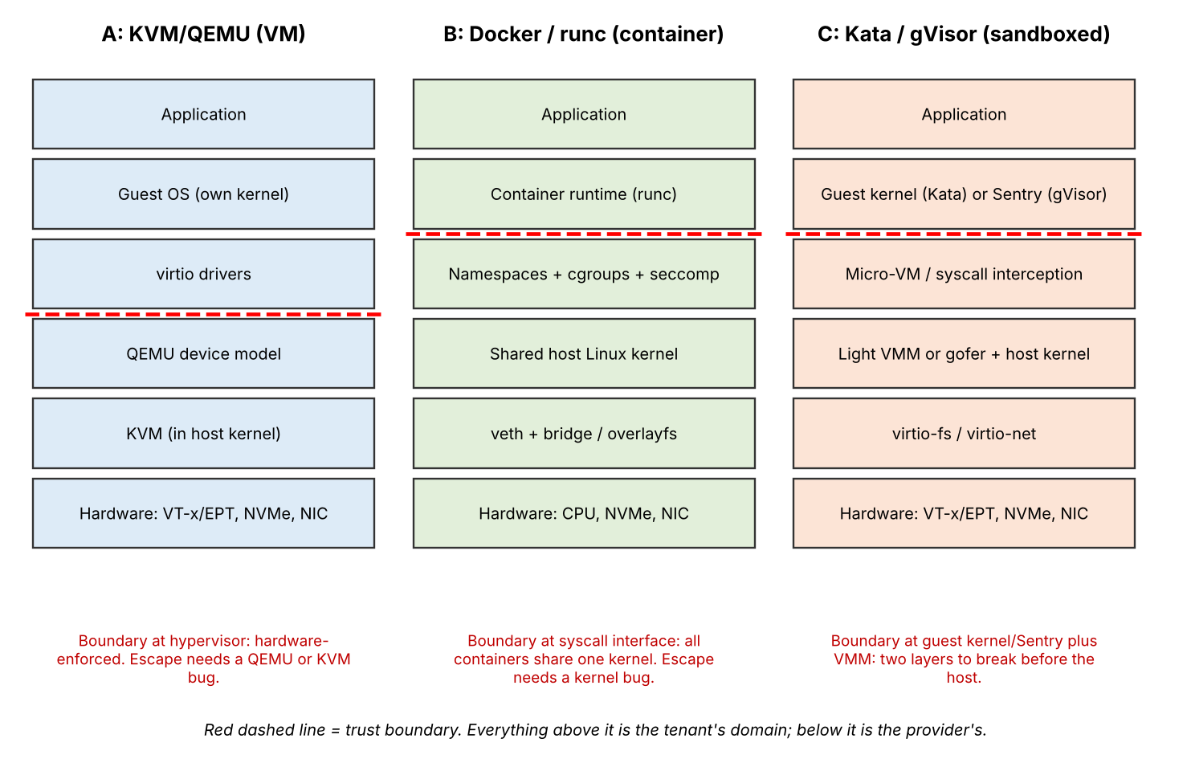
Figure . Layered architectures of the three suggested approaches with the trust boundary marked.
What to write for each approach
- Isolation mechanism. In KVM, the hypervisor uses processor virtualization support and extended page tables to keep guest environments apart, while QEMU provides virtual devices. Docker relies on Linux namespaces to separate process, network and file-system views, with cgroups controlling resource usage. Kata places each container workload inside a small virtual machine, giving it a separate guest kernel. In gVisor, the Sentry component handles many application system calls before they reach the host kernel.
- CPU handling. A VM receives virtual CPUs that are scheduled by the host. Some privileged instructions and device operations may require a VM exit. A normal container runs as a host process, so it uses the host scheduler directly and can be restricted with CPU quotas. Kata adds the scheduling layers of both the guest and host, while gVisor adds work when system calls are intercepted.
- Memory handling. A VM maps guest memory onto physical host memory through the hypervisor, using mechanisms such as extended page tables. When memory is oversubscribed, ballooning or swapping may be used. Containers use the host memory manager and can be limited through cgroups. Kata must reserve memory for each small guest environment, so its per-instance requirement is normally higher than a standard container.
- Storage and networking. A VM commonly accesses virtual disks and network cards through virtio devices. A container uses the host file system, often with overlayfs, and connects through a virtual Ethernet pair and bridge. Kata combines a lightweight VM with virtual devices, whereas gVisor can route file and network operations through its protected runtime components.
- EduCloud relevance. KVM is a suitable option for student information and database services because it provides a separate guest operating system. Docker is useful for web services that need quick deployment and efficient use of memory. Kata or gVisor can be considered for research applications that should not receive the same level of trust as core university services.

Task 2: Dominant overhead source
For every selected design, identify the operation that adds the greatest extra cost. Explain the layer where it occurs and connect it to the actual workload. For example, VM device handling may cause frequent exits, a container may experience contention in the shared kernel and virtual network, and a protected runtime may spend additional time processing system calls.
Approach | Likely dominant overhead | How it scales
KVM/QEMU | VM exits during virtual-device and interrupt handling, plus address-translation work | The number of exits rises with I/O activity; CPU contention also grows as more vCPUs share cores
Docker/runc | Shared-kernel scheduling and virtual Ethernet bridge processing | More containers and packets increase competition in common kernel and network components
Kata | Guest-to-host I/O transitions and the memory needed for each lightweight VM | Extra file and network transitions add cost; each pod also reserves guest memory
gVisor | System-call interception by the protected runtime | The additional work increases with the application's system-call frequency

This comparison matters because registration traffic contains a large number of small requests. Even a small delay added to each disk or network operation can become noticeable when thousands of requests arrive together. The analysis should therefore focus on repeated operations rather than only on the cost of starting a VM or container.
Turning the overhead into something you can model
A useful way to represent overhead is to multiply the number of operations by the extra time required for each operation. For a VM, estimated exit overhead per second is the exit count multiplied by 1.5 microseconds. If an application produces 8,000 I/O operations each second and an average of two exits are associated with each operation, the estimated exit count is 16,000 per second. The resulting time cost can then be included in the CPU model.
How the cost changes as co-location grows
Instance count and workload rate affect performance in different ways. Adding more instances increases competition for CPU cores, cache, memory bandwidth and shared devices. Increasing the request rate raises the number of exits, system calls or virtual-network operations performed each second. The model should consider both effects instead of assuming that instance count alone explains every slowdown.
In summary, KVM performance is influenced by the number of device-related exits, Docker by shared-kernel and virtual-network contention, and protected runtimes by the extra processing required for system calls or guest I/O. These are the main factors to observe during testing.

Task 3: Quantitative performance model
Begin with a list of symbols and clearly state the assumptions used in the calculations. Use the host specifications supplied in the question, then calculate CPU capacity, memory capacity, network or storage sharing, and the maximum safe instance density. The numerical values below are worked illustrations; replace assumed values with measurements from your own test environment where available.
CPU capacity
Let r represent the number of virtual CPUs assigned per physical core. The maximum CPU share available to one vCPU is approximately 1/r of a core before additional overhead is considered. If a VM performs E exits per second, the fraction of time spent handling exits is E multiplied by 1.5 microseconds. A further reduction is caused by steal time, represented by s(r), which generally becomes larger as more vCPUs compete for the same cores.
C_eff(r) = (1/r) x (1 - n_exit x 1.5e-6) x (1 - s(r))
Illustration: choose r = 4 and E = 12,000 exits per second. Exit processing consumes 12,000 × 1.5 microseconds, or 1.8% of one second. If the assumed steal time is 6%, the estimated capacity is (1/4) × (1 − 0.018) × (1 − 0.06), which is about 0.231 of a physical core per vCPU. For a protected runtime, include its additional system-call processing time; for an ordinary container, use the native system-call cost given in the question.
Memory
Memory capacity depends on the RAM left after reserving space for the host and on the amount required by each instance. The calculation must also include the memory used by the virtualization layer, device model or runtime. Once the available memory is exhausted, swapping or other memory-reclamation methods can cause a significant reduction in performance.
N_mem = floor( (M_host - M_reserve) / (M_vm + M_overhead) )
Illustration: reserve 40 GB from the 512 GB host for the operating system and management services. This leaves 472 GB for workloads. If each VM requires 8 GB and its additional overhead is assumed to be 0.25 GB, the estimated limit is floor(472 / 8.25), which gives 57 VMs. A standard container with a smaller assumed overhead may allow a slightly higher count. These figures are estimates and should be adjusted to match the selected platform.
I/O and network
When several instances use the same 25 Gbps network interface, they must share its available capacity. The usable bandwidth is lower than the line rate because each architecture has processing overhead. Let η represent the measured efficiency of the selected virtual network path and N the number of active instances.
T_inst(N) = min( R_line x eta_path / N , R_cpu_limit )
For example, if η is assumed to be 0.90 and eight instances share the interface equally, the estimated bandwidth per instance is (25 × 0.90) / 8, or approximately 2.81 Gbps. CPU processing can reduce this further when packet rates are high. Apply the same method to disk performance using the bandwidth or IOPS measured with the selected storage benchmark.
Density against a service-level target
The safe density is not simply the largest number of instances that can be started. First calculate the CPU, memory and I/O limits. Then select the lowest limit and check whether the application still meets the service target. Reduce the instance count until performance degradation remains within the chosen 10% limit.
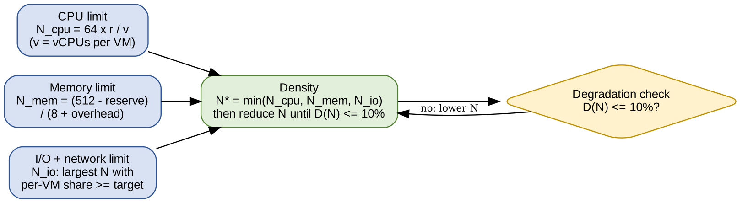
Figure . How the CPU, memory and I/O limits combine into the density you can promise.

Task 4 : Behaviour under different operating conditions
Explain each operating condition by describing the activity inside the virtualization layer and its effect on response time and throughput. Use the values from Task 3 to support the explanation, rather than presenting an isolated table.
- Best condition: A small number of instances run with low CPU overcommit and sufficient memory. CPU-intensive tasks can perform well when vCPUs are scheduled consistently and storage or network traffic is light. Containers are close to native execution for many workloads because they use the host kernel. A protected runtime performs better when the application does not make frequent system calls.
- Normal condition: During registration, many users access the web portal and database at the same time. Virtual disks, network interfaces and system calls are used repeatedly. As queues become busier, each request may wait longer before it is processed. Therefore, average throughput may remain reasonable while response time, especially for slower requests, increases.
- Heavy-load condition: Performance can decline when another tenant consumes most of the CPU, cache or memory bandwidth. If the host runs short of RAM, swapping adds slow storage operations. Live migration can also use network bandwidth and CPU cycles while a VM is being moved. A shared I/O queue may become congested when many workloads generate requests together.
Using the model to explain the numbers
A simple queueing estimate helps explain why delays rise quickly near full utilisation. If the utilisation of a device is 0.6, the approximate response time using S/(1 − ρ) is 2.5 times the service time. At utilisation 0.9, it becomes 10 times the service time. This illustrates why a small increase in load near capacity can create a large increase in latency.
Under noisy-neighbour conditions, VMs have separate guest operating systems but still compete for physical resources such as cache, RAM bandwidth and storage. Containers share the host kernel, so contention can also occur in common kernel services and network components. A sandboxed runtime adds another boundary, but it does not remove competition for the underlying processor, memory or devices.

Task 5 : Security threat and vulnerability analysis
Prepare a separate threat assessment for each architecture. Consider the hypervisor and virtual-device interfaces in VM systems, the shared host kernel in containers, the runtime used by protected containers, and common management services such as image repositories and virtual networks. For each threat, explain the possible effect on the confidentiality, integrity or availability of student information.
Threat | KVM/QEMU | Docker/runc | Kata / gVisor
VM or container escape | A flaw in the hypervisor or virtual-device service could allow a guest to affect the host | A kernel or container-runtime weakness may cross the shared-kernel boundary | An attacker would need to compromise the guest boundary or protected runtime and then reach the host layer
Cross-tenant side channels | Shared processor caches and SMT resources may expose activity between guests | Hardware sharing remains, and common kernel data structures may add exposure | Hardware side channels can remain; the extra runtime boundary does not remove shared hardware
Unpatched guests and sprawl | Guest operating systems and their packages must be updated separately | The host kernel is updated centrally, but application images still need regular rebuilding | Both the host and the guest/runtime components require patch management
Image tampering | An altered VM disk or snapshot could introduce untrusted software | A modified container layer may distribute unsafe code to multiple services | Container images and the lightweight guest image must both be verified
Insecure live migration | Migration data needs protection while it moves between hosts | Checkpoint and restore operations also require strict access controls | Migration security depends on the underlying VM platform and its configuration
Virtual-network spoofing | Incorrect virtual-switch rules may allow unwanted traffic between tenants | A default bridge can permit more communication than intended unless policies are applied | Separate virtual interfaces help, but network policy is still required

Use a consistent scale such as low, medium and high for the risk ratings. Add a short reason beside every rating. The rating should reflect the architecture and the controls actually enabled in the proposed EduCloud design, not simply assume that one technology is always safe.

Task 6 : Isolation-performance trade-off
Use the performance calculations and threat assessment to create a decision model. The model should show how the university chooses a virtualization method and instance count while meeting both performance and isolation requirements.
- Decision variables can include the platform assigned to each workload, the number of instances placed on a host, whether a host is dedicated to one tenant, and whether simultaneous multithreading is enabled.
- A suitable objective is to reduce the total number of physical hosts while keeping the operational risk within an acceptable range. Another option is to minimise a combined score that includes host cost and the remaining security risk.
- The constraints should include a maximum 10% performance loss, a minimum isolation level for the SIS, the CPU and RAM limits calculated in Task 3, and the total limit of 16 physical hosts.
min H = sum over classes t of ceil( N_t / n_t )
s.t. D_a(n_t) <= 0.10; Iso(a, mitigations) >= Iso_SIS; n_t <= min(N_cpu, N_mem, N_io); H <= 16
If a weighted score is used, explain the importance assigned to host usage and security risk. Since student records are sensitive, the security component should receive a meaningful weight rather than being treated as a minor cost.
A worked illustration
Worked illustration: assume that the SIS requires 60 VMs, the LMS and examination portal require 120 instances, and research teams require another 100 instances. If a host can safely support 57 VMs according to the memory estimate, the SIS would need at least two hosts when placed in its own pool. Calculate the other pools in the same way, then check CPU, network and isolation limits before accepting the result.
How to solve it
Because there are only a few platform and placement choices, the alternatives can be checked in a spreadsheet. Remove any option that breaks a performance or security constraint, then compare the remaining options by total host count and risk. Repeat the calculation with a stricter performance target, such as 5%, to see whether the preferred design changes.

Task 7 : Evaluate mitigations
Choose at least three controls that directly address the risks identified in Task 5. For every control, describe the threat it reduces, the risk that remains, its estimated resource or capacity cost, and whether that cost is acceptable for a service containing student records.
Mitigation | Threat addressed | Model-based cost (example) | Residual risk
SMT off | Limits attacks that rely on sibling threads sharing one physical core | The host exposes fewer logical CPUs, so the available scheduling capacity is reduced | Other cache- and memory-based side channels may still exist
Dedicated hosts for SIS | Keeps sensitive SIS workloads away from other tenants | More physical machines may be needed and consolidation becomes lower | Management-plane and shared-storage risks still need separate controls
Sandboxed runtime (Kata/gVisor) | Adds a stronger boundary around workloads that should not share the host kernel directly | Extra guest or runtime memory and processing reduce the number of instances per host | The hypervisor or protected-runtime software can still contain vulnerabilities
Image signing | Prevents unapproved or modified software images from being deployed | Adds image verification steps but usually little runtime processing cost | A compromised signing key or build pipeline can still produce trusted malicious images
Evaluating each mitigation
For example, disabling SMT can reduce exposure to attacks that depend on two tenants sharing sibling threads on one physical core. However, attacks using shared caches or other hardware resources may still be possible. The host also loses some logical CPU capacity, so the CPU-density calculation must be repeated before this control is adopted.
Estimate each control using the part of the model it changes. A sandboxed runtime affects memory use and system-call or I/O processing. Dedicated SIS hosts increase the number of physical machines required. Image signing and network segmentation usually add little processing overhead, but they require reliable administration, key protection and policy maintenance.
For the SIS, make strong tenant separation, controlled access to management interfaces and verified software images mandatory. Other controls can be selected according to the measured risk and available capacity. Explain why the chosen combination gives an acceptable balance instead of claiming that every control must always be enabled.

Task 8 : Implement and test
Create a small test setup using the selected VM, container and protected-runtime platforms. Keep the CPU, memory and storage limits equal wherever possible, run the same workload on each platform, and repeat every test several times. If the available laptop cannot support the full instance scale, document the smaller test size and explain this limitation.
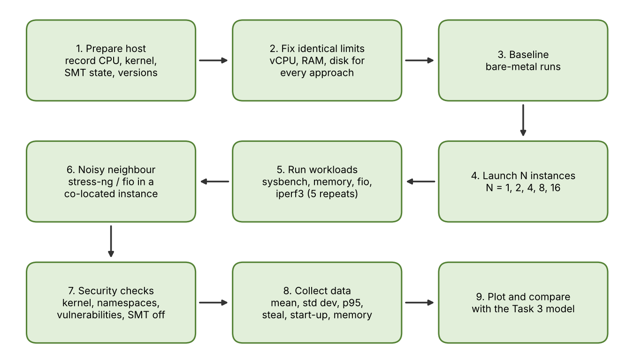
Figure 4. Experimental workflow from host preparation to comparison with the model.
- Use a CPU benchmark such as sysbench, a memory workload, fio for storage and iperf3 for network throughput. Record the configuration and version of each tool so the tests can be repeated.
- For the interference test, run a fixed workload in one instance while another instance generates CPU, memory or disk activity. Compare the victim workload's latency and throughput before and during the additional load.
- For a practical isolation check, compare the kernel version seen by a container with the host, inspect namespace and cgroup settings, and review the host's reported CPU vulnerability status. Record which protection is enabled for the VM or sandboxed-runtime test.
- Save the commands, configuration files and raw outputs in one project folder. Add a short note describing the host hardware, operating system, virtualization software and benchmark versions.
Example commands to adapt
The following commands are examples for a controlled test. Adjust the thread count, run duration and file size to suit the available computer, and use equivalent settings for each platform.
# CPU: 60 s run on 2 threads
sysbench cpu --threads=2 --time=60 run
# Memory bandwidth
sysbench memory --threads=2 --memory-total-size=20G run
# Disk: random 4k read/write with latency percentiles
fio --name=rw --rw=randrw --bs=4k --iodepth=16 --runtime=60 --time_based --direct=1 --size=2G
# Network: server in one instance, client in another
iperf3 -s and iperf3 -c <server> -t 30 -P 4
# Noisy neighbour in a co-located instance
stress-ng --cpu 2 --vm 1 --vm-bytes 2G --timeout 120s
# Security checks
uname -r; ls -l /proc/self/ns; grep . /sys/devices/system/cpu/vulnerabilities/*

Choosing and justifying test cases
Each benchmark should verify one part of the analytical model. CPU results help assess the effective-capacity estimate, memory tests show whether the chosen limits are realistic, fio measures the storage path, and iperf3 provides a value for network efficiency. The interference test checks whether the worst-case explanation matches the observed behaviour.

Task 9 : Record experimental performance
Record throughput, average latency and 95th-percentile latency for each run. Also note CPU steal time, context switches and VM exits when the platform exposes those counters. Measure instance start-up time and memory use, then compare each result with a bare-metal baseline using the same benchmark settings.
Statistics and presentation
Run each configuration at least five times and calculate the mean and standard deviation. State whether any warm-up run was excluded. For throughput, calculate degradation as (baseline − measured) / baseline. For latency, calculate the increase as (measured − baseline) / baseline. Include the number of trials and units beside every result.
Keep the original benchmark output as well as the spreadsheet or script used to create the tables and graphs. Do not remove an unusual result without explaining it; investigate whether it was caused by background activity, thermal changes or a configuration difference.

Task 10 : Compare theory with experiment
Compare the predicted and measured results for the same instance counts. Calculate the percentage difference and explain why the model may not match the experiment exactly. Possible reasons include caching, scheduling, nested virtualization, temperature-related CPU throttling and differences in the virtual I/O path. Use your actual measurements to identify the best-scaling approach.
A structure that works
- Step 1: for each approach, put predicted and measured degradation for the same instance counts on one graph or in one table.
- Step 2: calculate the relative error for each measurement using (measured value − predicted value) / predicted value. Summarise the absolute errors to show how closely the model follows the test results.
- Step 3: say whether the trend matches (for example both rise roughly linearly with instances, or measured degradation bends upward earlier than predicted), separate from whether the absolute numbers match.
- Step 4: investigate large differences. Nested virtualization may add extra exits, a laptop may reduce CPU speed when it becomes hot, and file-system caching may improve container storage results. Mention only causes that are relevant to your setup.
- Step 5: say which approach scaled best (smallest growth of degradation as instances increase) and whether this agrees with your Task 4 expectation.
Finally, review the threat analysis in light of the measurements. If a protected runtime gives noticeably lower throughput for a database workload, explain whether a separate VM host pool would provide a better practical balance for the SIS.

Task 11 : Recommend and defend
A mixed architecture is a practical choice because the university workloads do not all have the same requirements. Place the SIS and its database on KVM virtual machines with strict host separation. Use containers for stateless LMS web services where rapid scaling and density are important. Place less-trusted research jobs in a protected runtime or a separate host pool. Confirm the final placement using the measured performance and security results.
Comparison table
Complete the comparison using the results from your own tests. Avoid entering assumed benchmark results as if they were measured. Where a test could not be performed, clearly label the value as an estimate or unavailable.
Criterion | KVM/QEMU (VM) | Docker (container) | Kata / gVisor
Modelled density | Usually lower because each VM needs its own guest resources | Often higher because containers share the host kernel | Generally between a standard VM and a normal container
Measured overhead | From your Task 9 data | From your Task 9 data | From your Task 9 data
Isolation strength | Strong separation through the hypervisor boundary | Relies on host-kernel isolation controls | Adds a guest or user-space protection layer
Patching effort | Host and individual guest systems must be patched | Host kernel and application images must be maintained | Host, guest image and runtime all need updates
Migration | Supported by many VM platforms | Usually handled through restart or orchestration | Depends on the selected protected-runtime implementation

Operations and growth
Operational planning should cover guest and host patching, image updates, monitoring and migration. VM guests need their own operating-system updates, while containers depend on a maintained host kernel and regularly rebuilt images. Use a controlled image registry with scanning and signing. Network policies should restrict communication between the SIS, LMS and research environments.
State the limits of the experiment, such as a small number of instances, laptop hardware or nested virtualization. Explain how these restrictions may affect the accuracy of the measurements and avoid presenting small-scale results as a full data-centre benchmark.

Task 12 : Re-evaluate for external tenants
Treat the new external-research requirement as a change to both workload and trust assumptions. Answer each part below and connect the decision to the calculations and tests already completed.
- A. Impact (2). External collaborators should be treated as separate, less-trusted tenants. Their Spark or Hadoop jobs may run for long periods and generate heavy disk and network traffic. Registration demand also rises to about three times its normal level. These changes increase resource contention and make strict separation of student records more important.
- B. Evaluate the original design (2). Recalculate CPU, memory and network demand using the higher registration load and the research I/O profile. Check whether the design still stays within the 10% degradation target. Also decide whether the existing trust boundaries are strong enough when external users share the platform.
- C. Adapt or redesign (2). A suitable modification is to keep the protected SIS pool, create a separate pool for external research jobs, and use a stronger runtime boundary for workloads that must share infrastructure. Consider dedicated network capacity or SR-IOV for data-heavy jobs and encrypted live migration where supported. Explain the effect on host count, density and attack surface.
- D. Defend (2). Support the final choice with the revised model, the noisy-neighbour experiment, the mitigation results and the extra host or network cost. The recommendation should show why the selected separation is worth the resources it consumes.
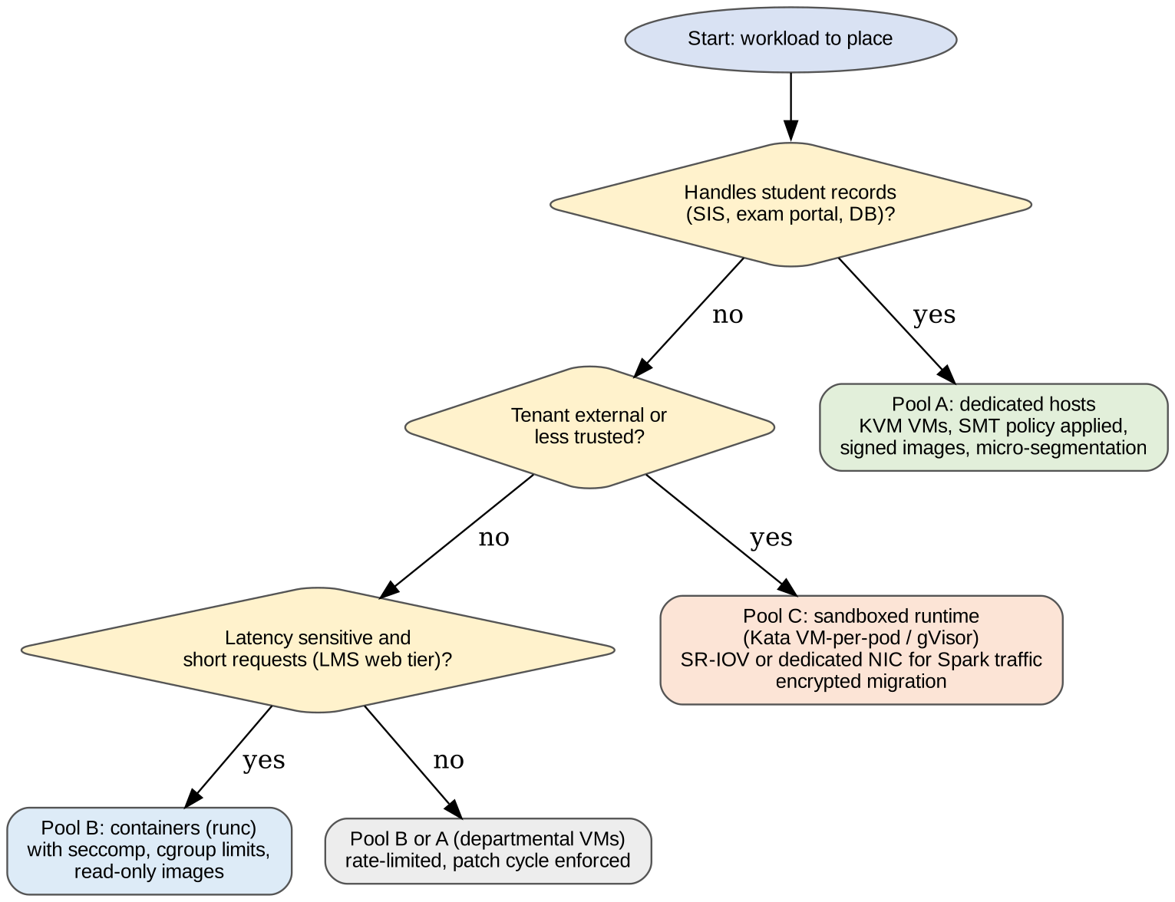
Figure 5. One possible placement policy for the redesign: separate host pools by data sensitivity and trust level.
One possible revised arrangement is to leave SIS workloads on dedicated VM hosts, place LMS services in a general-purpose container pool, and allocate external research workloads to a separate protected pool. Data-heavy jobs can receive reserved network capacity, while migration traffic should be encrypted. Calculate the additional host requirement and state the expected effect on density.

4. Common ways to lose marks
- Quoting overhead percentages from papers instead of deriving them from the given 1.5 µs and 0.2 µs values.
- Counting two configurations of one hypervisor as different approaches.
- Presenting tables with no explanation of what happens inside the virtualization layer.
- Running experiments with different resource limits per approach, or with only one repetition.
- Recommending the most secure or the fastest option without balancing both.
- Treating Task 12 as a fresh essay instead of re-using your model and measured results.

5. Final checklist
- Three distinct approaches with labelled diagrams and trust boundaries
- Symbols table, assumptions and worked numbers for CPU, memory, I/O and density
- Condition analysis explained by mechanisms, not just numbers
- Threat matrix with at least four threat categories and CIA impact
- Trade-off formulation using your own numbers
- At least three mitigations with residual risk and model-based cost
- Reproducible lab description, a noisy-neighbour experiment and one security check
- At least one table and two graphs with mean ± standard deviation
- Predicted versus measured error analysis
- Recommendation covering performance, security, operations and growth
- Task 12 parts A to D, each citing earlier results

